**1.create an instance using data block in a vpc which is created manually outside of terraform**

**main.tf file**

# Configure the AWS provider

provider "aws" {

    region = "ap-south-1"

}

# Create a VPC

resource "aws_vpc" "terran_vpc" {

    cidr_block = "10.0.0.0/16"

    tags = {

        Name = "terran-vpc"

    }

}

# Create a Subnet

resource "aws_subnet" "terran_subnet" {

    vpc_id                  = aws_vpc.terran_vpc.id

    cidr_block              = "10.0.1.0/24"

    availability_zone       = "ap-south-1b"

    map_public_ip_on_launch = true

    tags = {

        Name = "terran-subnet"

    }

}

# Create an Internet Gateway

resource "aws_internet_gateway" "terran_igw" {

    vpc_id = aws_vpc.terran_vpc.id

    tags = {

        Name = "terran-igw"

    }

}

# Create a Route Table

resource "aws_route_table" "terran_rt" {

    vpc_id = aws_vpc.terran_vpc.id

    route {

        cidr_block = "0.0.0.0/0"

        gateway_id = aws_internet_gateway.terran_igw.id

    }

    tags = {

        Name = "terran-rt"

    }

}

# Associate Route Table with Subnet

resource "aws_route_table_association" "terran_rt_association" {

    subnet_id      = aws_subnet.terran_subnet.id

    route_table_id = aws_route_table.terran_rt.id

}

# Create a Security Group

resource "aws_security_group" "terran_sg" {

    description = "Allow SSH traffic"

    vpc_id      = aws_vpc.terran_vpc.id

ingress {

        description = "Allow SSH"

        from_port   = 22

        to_port     = 22

        protocol    = "tcp"

        cidr_blocks = ["0.0.0.0/0"]

    }

    egress {

        from_port   = 0

        to_port     = 0

        protocol    = "-1"

        cidr_blocks = ["0.0.0.0/0"]

    }

    tags = {

        Name = "terran-sg"

    }

}

# Create an EC2 Instance

resource "aws_instance" "terran_instance" {

    subnet_id       = aws_subnet.terran_subnet.id

    ami             = "ami-0ad21ae1d0696ad58"

    instance_type   = "t2.micro"

    key_name        = "terraform"

    security_groups  = [aws_security_group.terran_sg.id]  # Use security_group_ids instead of security_group_id

    tags = {

        Name = "terraform-instance"

    }

}

**Before initializing tf file**

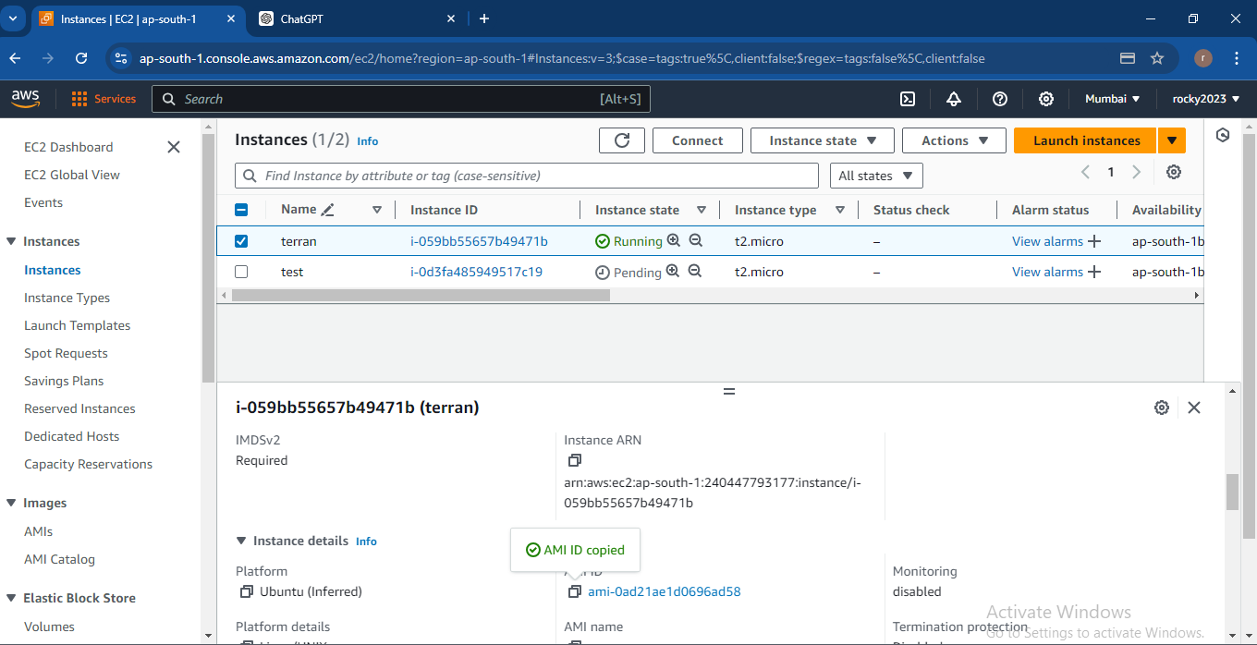

**After initializing tf file terraform-instance created…**

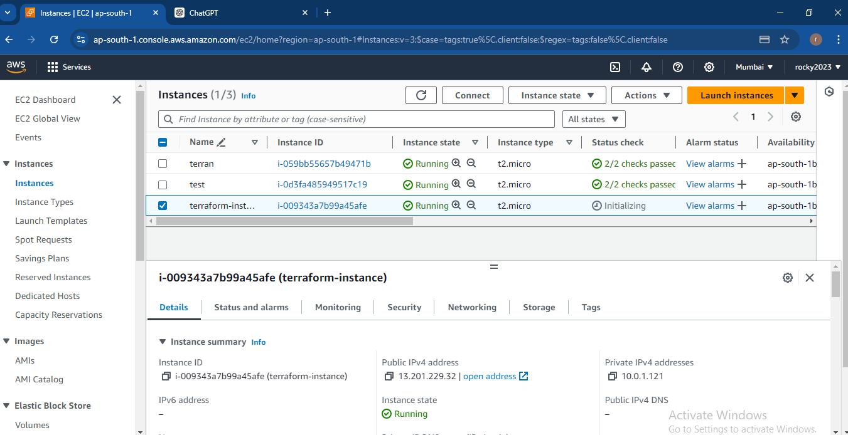

**Executed result with instance id**

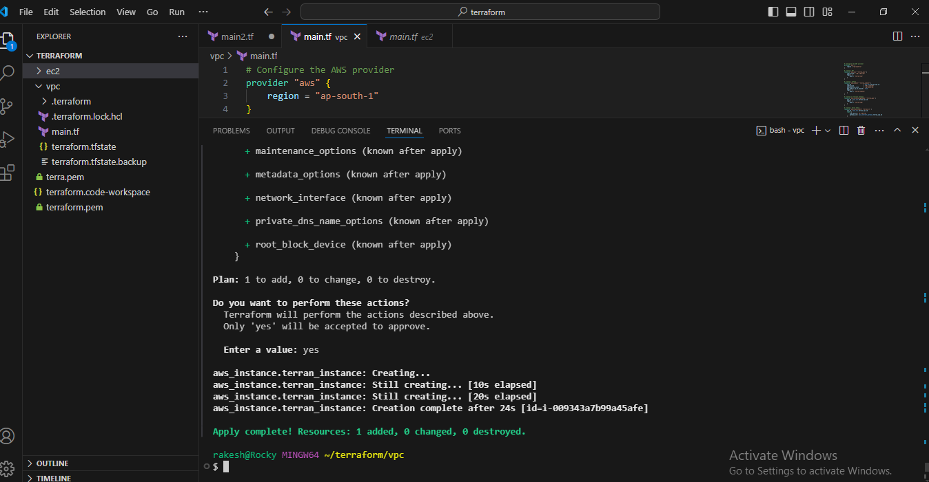

**2)**  **create instances in multiple regions with same config file using an alias**

**Main.tf file**

# Configure the AWS provider for ap-south-1

provider "aws" {

    alias  = "ap_south"

    region = "ap-south-1"

}

# Configure the AWS provider for us-west-1

provider "aws" {

    alias  = "us_west"

    region = "us-west-1"

}

# Define resources in ap-south-1

# Create a VPC in ap-south-1

resource "aws_vpc" "terran_vpc_ap_south" {

    provider = aws.ap_south

    cidr_block = "10.0.0.0/16"

    tags = {

        Name = "terran-vpc-ap-south"

    }

}

# Create a Subnet in ap-south-1

resource "aws_subnet" "terran_subnet_ap_south" {

    provider               = aws.ap_south

    vpc_id                 = aws_vpc.terran_vpc_ap_south.id

    cidr_block             = "10.0.1.0/24"

    availability_zone      = "ap-south-1b"

    map_public_ip_on_launch = true

    tags = {

        Name = "terran-subnet-ap-south"

    }

}

# Create a Security Group in ap-south-1

resource "aws_security_group" "terran_sg_ap_south" {

    provider    = aws.ap_south

    description = "Allow SSH traffic"

    vpc_id     = aws_vpc.terran_vpc_ap_south.id

    ingress {

        description = "Allow SSH"

        from_port   = 22

        to_port     = 22

        protocol    = "tcp"

        cidr_blocks = ["0.0.0.0/0"]

    }

    egress {

        from_port   = 0

        to_port     = 0

        protocol    = "-1"

        cidr_blocks = ["0.0.0.0/0"]

    }

    tags = {

        Name = "terran-sg-ap-south"

    }

}

# Create an EC2 Instance in ap-south-1

resource "aws_instance" "terran_instance_ap_south" {

    provider            = aws.ap_south

    ami                  = "ami-0ad21ae1d0696ad58"  # Verify the AMI ID is valid in ap-south-1

    instance_type        = "t2.micro"

    subnet_id            = aws_subnet.terran_subnet_ap_south.id

    key_name             = "terraform"

    security_groups   = [aws_security_group.terran_sg_ap_south.id]

    tags = {

        Name = "terraform-instance-ap-south"

    }

}

# Define resources in us-west-1

# Create a VPC in us-west-1

resource "aws_vpc" "terran_vpc_us_west" {

    provider = aws.us_west

    cidr_block = "10.1.0.0/16"

    tags = {

        Name = "terran-vpc-us-west-1"

    }

}

# Create a Subnet in us-west-1

resource "aws_subnet" "terran_subnet_us_west" {

    provider               = aws.us_west

    vpc_id                 = aws_vpc.terran_vpc_us_west.id

    cidr_block             = "10.1.1.0/24"

    availability_zone      = "us-west-1a"

    map_public_ip_on_launch = true

    tags = {

        Name = "terran-subnet-us-west-1"

    }

}

# Create a Security Group in us-west-1

resource "aws_security_group" "terran_sg_us_west" {

    provider    = aws.us_west

    description = "Allow SSH traffic"

    vpc_id     = aws_vpc.terran_vpc_us_west.id

    ingress {

        description = "Allow SSH"

        from_port   = 22

        to_port     = 22

        protocol    = "tcp"

        cidr_blocks = ["0.0.0.0/0"]

    }

    egress {

        from_port   = 0

        to_port     = 0

        protocol    = "-1"

        cidr_blocks = ["0.0.0.0/0"]

    }

    tags = {

        Name = "terran-sg-us-west-1"

    }

}

# Create an EC2 Instance in us-west-1

resource "aws_instance" "terran_instance_us_west" {

    provider            = aws.us_west

    ami                  = "ami-0ff591da048329e00"  # Verify the AMI ID is valid in us-west-1

    instance_type        = "t2.micro"

    subnet_id            = aws_subnet.terran_subnet_us_west.id

    key_name             = "qpa-test"

    security_groups  = [aws_security_group.terran_sg_us_west.id]

    tags = {

        Name = "terraform-instance-us-west-1"

    }

}

**Executed results for creating instances in multiple regions**

**1)ap-south-1**

**2)us-west-1**

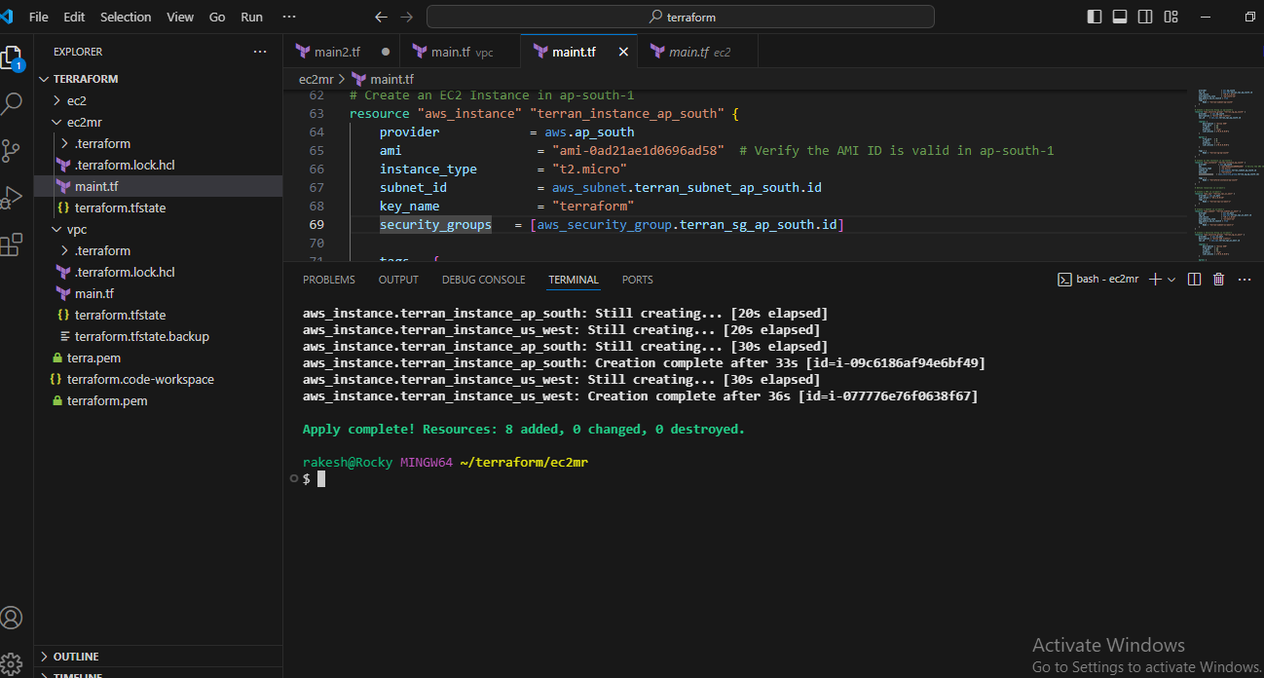

**Terraform instance at ap-south-1 region**

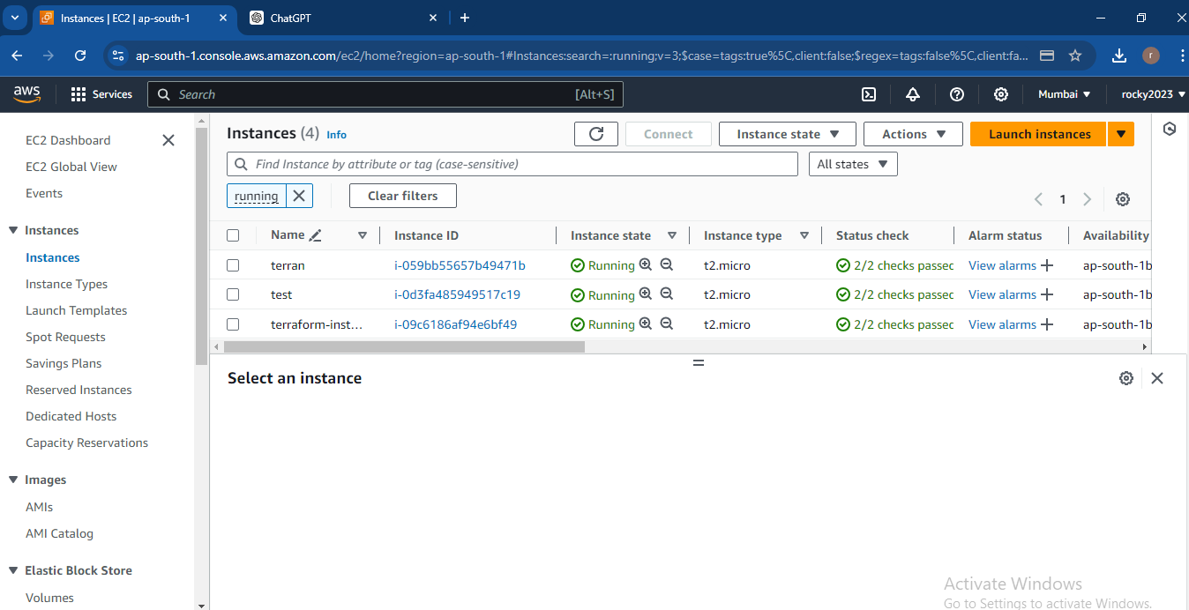

**Us-west-1 region**

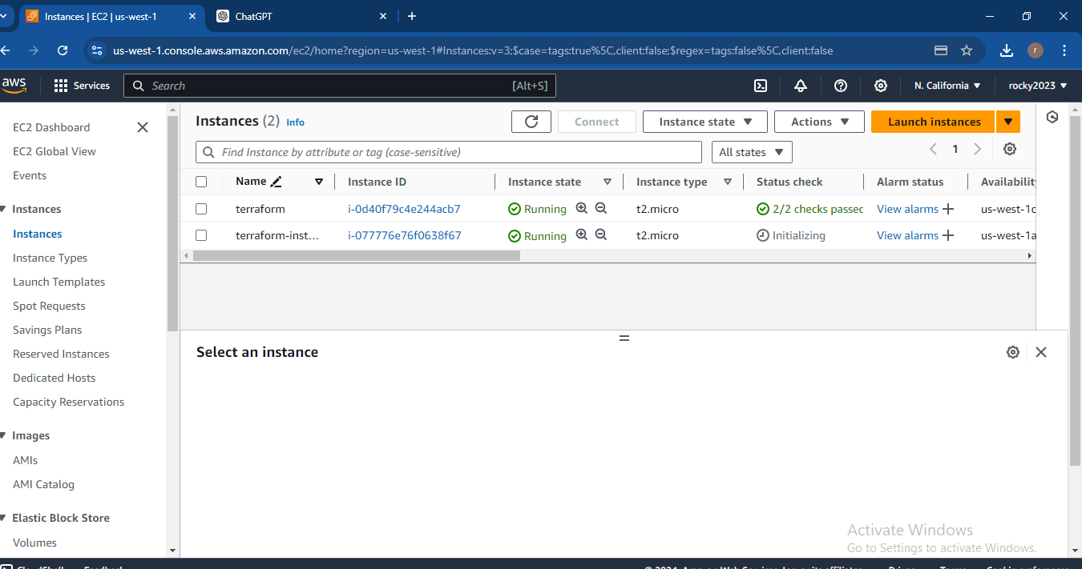

**3) Create multiple instances using for_each**

# Configure the AWS provider for ap-south-1

provider "aws" {

  alias  = "ap_south"

  region = "ap-south-1"

}

# Define a map of instance configurations

locals {

  instance_configs = {

    "instance1" = {

      ami           = "ami-0ad21ae1d0696ad58"  # Verify AMI ID for ap-south-1

      instance_type = "t2.micro"

      key_name      = "terraform"

      subnet_id     = aws_subnet.terran_subnet_ap_south.id

      security_groups = [aws_security_group.terran_sg_ap_south.id]

      tags = {

        Name = "terraform-instance-1"

      }

    },

    "instance2" = {

      ami           = "ami-0ad21ae1d0696ad58"  # Verify AMI ID for ap-south-1

      instance_type = "t2.micro"

      key_name      = "terraform"

      subnet_id     = aws_subnet.terran_subnet_ap_south.id

      security_groups = [aws_security_group.terran_sg_ap_south.id]

      tags = {

        Name = "terraform-instance-2"

      }

    },

    "instance3" = {

      ami           = "ami-0ad21ae1d0696ad58"  # Verify AMI ID for ap-south-1

      instance_type = "t2.micro"

      key_name      = "terraform"

      subnet_id     = aws_subnet.terran_subnet_ap_south.id

      security_groups = [aws_security_group.terran_sg_ap_south.id]

      tags = {

        Name = "terraform-instance-3"

      }

    }

  }

}

# Create a VPC in ap-south-1

resource "aws_vpc" "terran_vpc_ap_south" {

  provider  = aws.ap_south

  cidr_block = "10.0.0.0/16"

  tags = {

    Name = "terran-vpc-ap-south"

  }

}

# Create a Subnet in ap-south-1

resource "aws_subnet" "terran_subnet_ap_south" {

  provider               = aws.ap_south

  vpc_id                 = aws_vpc.terran_vpc_ap_south.id

  cidr_block             = "10.0.1.0/24"

  availability_zone      = "ap-south-1b"

  map_public_ip_on_launch = true

  tags = {

    Name = "terran-subnet-ap-south"

  }

}

# Create a Security Group in ap-south-1

resource "aws_security_group" "terran_sg_ap_south" {

  provider    = aws.ap_south

  description = "Allow SSH traffic"

  vpc_id      = aws_vpc.terran_vpc_ap_south.id

  ingress {

    description = "Allow SSH"

    from_port   = 22

    to_port     = 22

    protocol    = "tcp"

    cidr_blocks = ["0.0.0.0/0"]

  }

  egress {

    from_port   = 0

    to_port     = 0

    protocol    = "-1"

    cidr_blocks = ["0.0.0.0/0"]

  }

  tags = {

    Name = "terran-sg-ap-south"

  }

}

# Create EC2 Instances in ap-south-1 using for_each

resource "aws_instance" "terran_instance_ap_south" {

  for_each = local.instance_configs

  provider            = aws.ap_south

  ami                  = each.value.ami

  instance_type        = each.value.instance_type

  subnet_id            = each.value.subnet_id

  key_name             = each.value.key_name

  security_groups   = each.value.security_groups

  tags = each.value.tags

}

**Executed result**

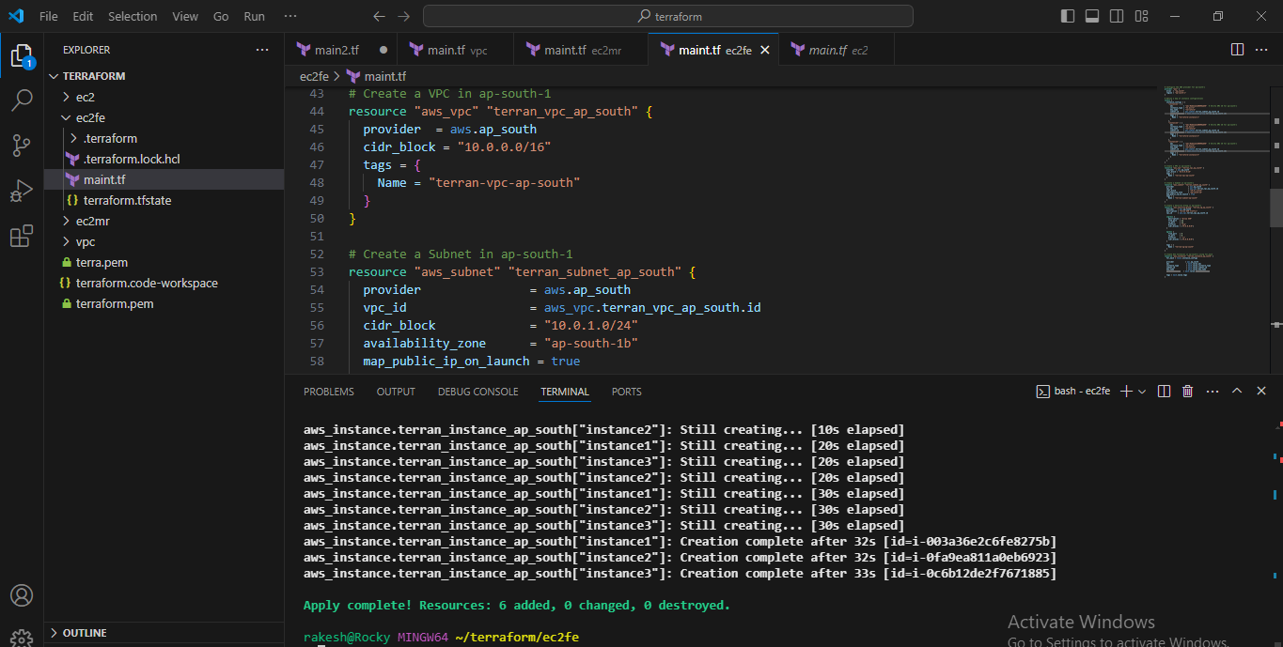

**Created multiple instances in aws that initializing instances**

